1) Distributor Dash Board:
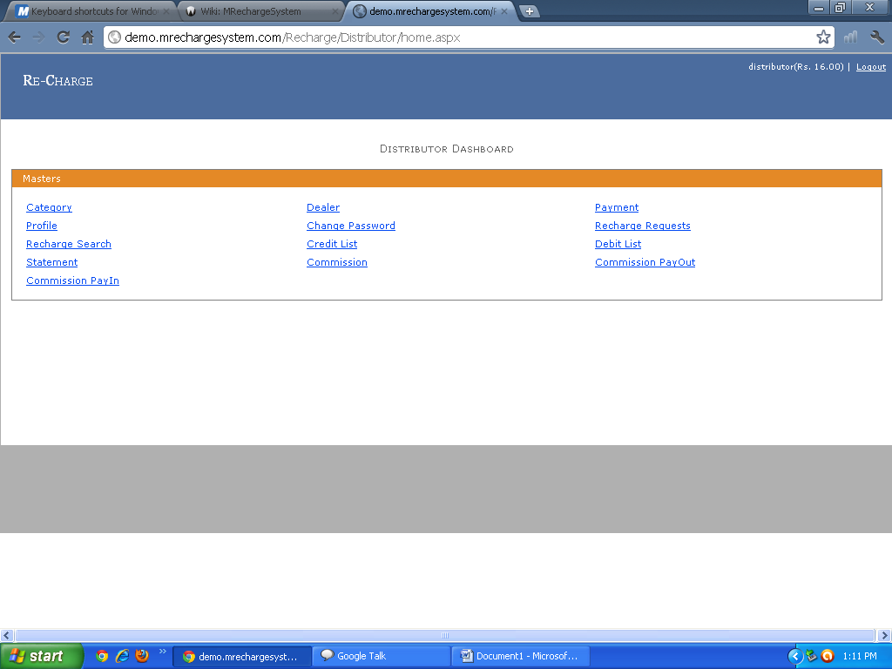2) Category: Distributor Can See the different type of Category and Admin can also Add Delete and Edit the Category.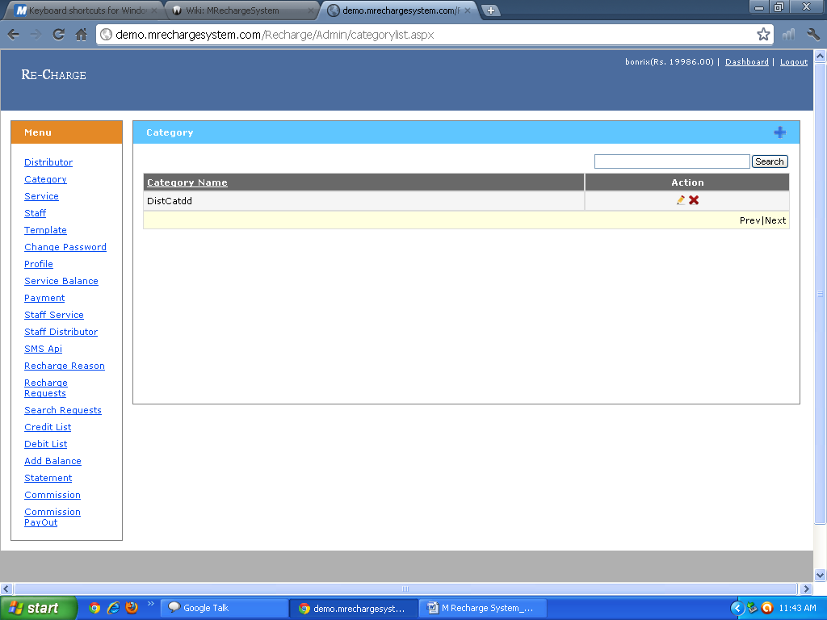

3) Dealer: Distributor can see all the Information Regarding the Dealer.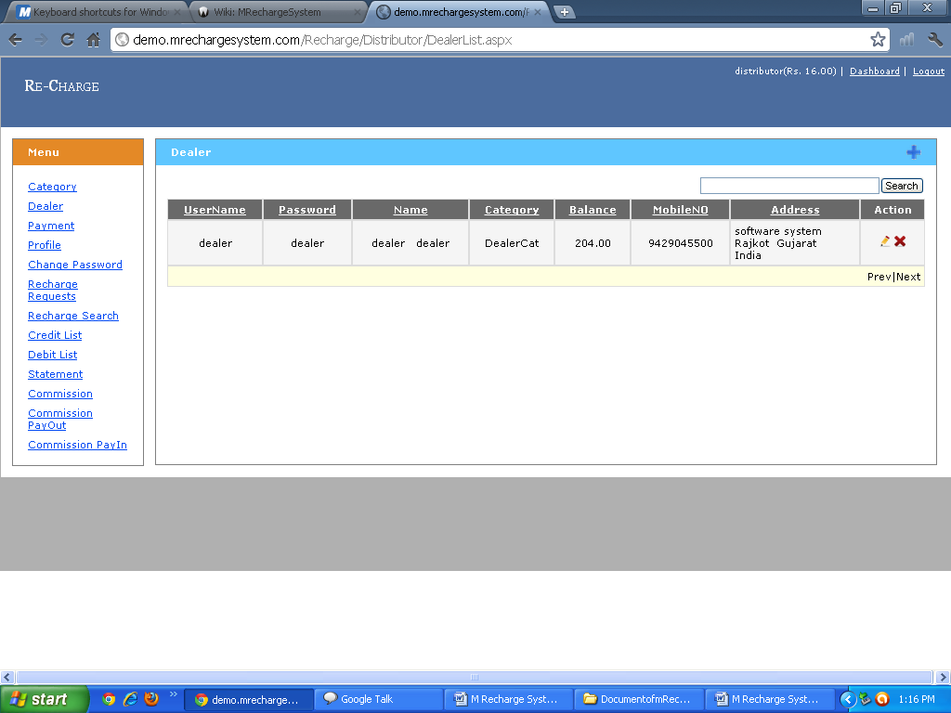
4) Payment: Distributor can fill the Information Regrading Dealer Payment and After that Distributor can Show the Payment Information 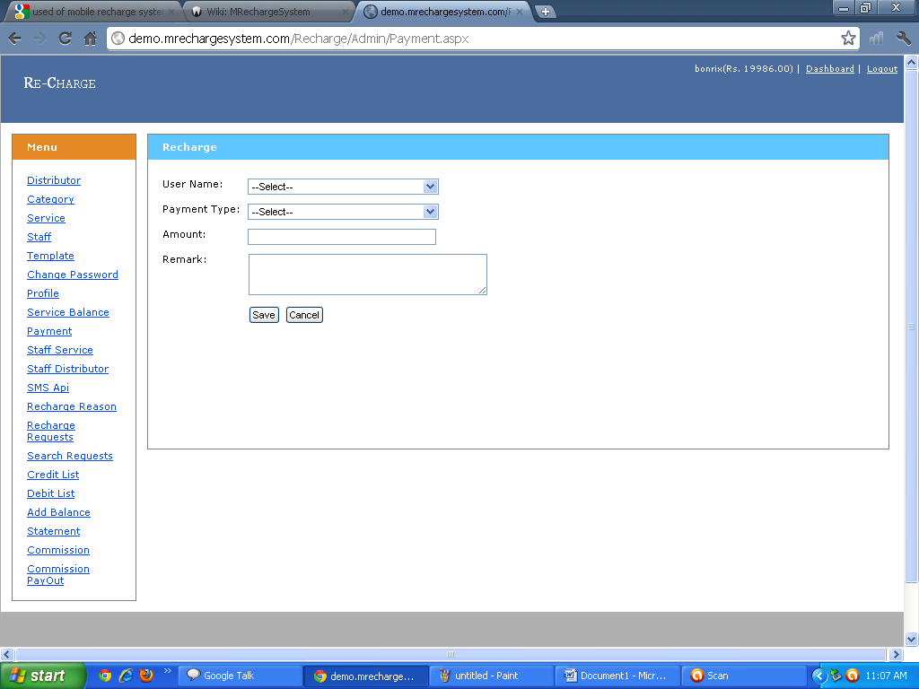

5) Distributor Profile: Distributor can see his Profile Information and he can also Edit his Information 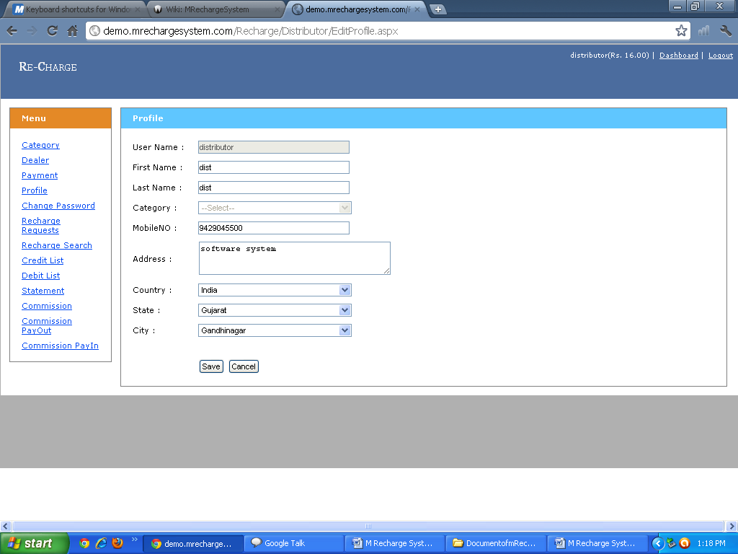

6) Change Password:Distributor Can Also change his Password 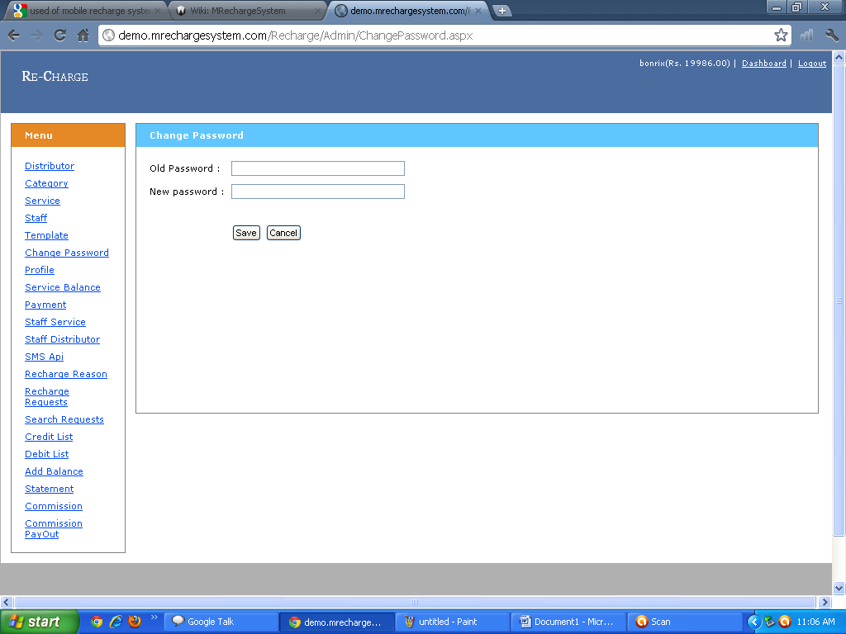

7) My Reacharge Request:Distributor can see The Information Regarding Recharge Request of Dealer,User and Staff .
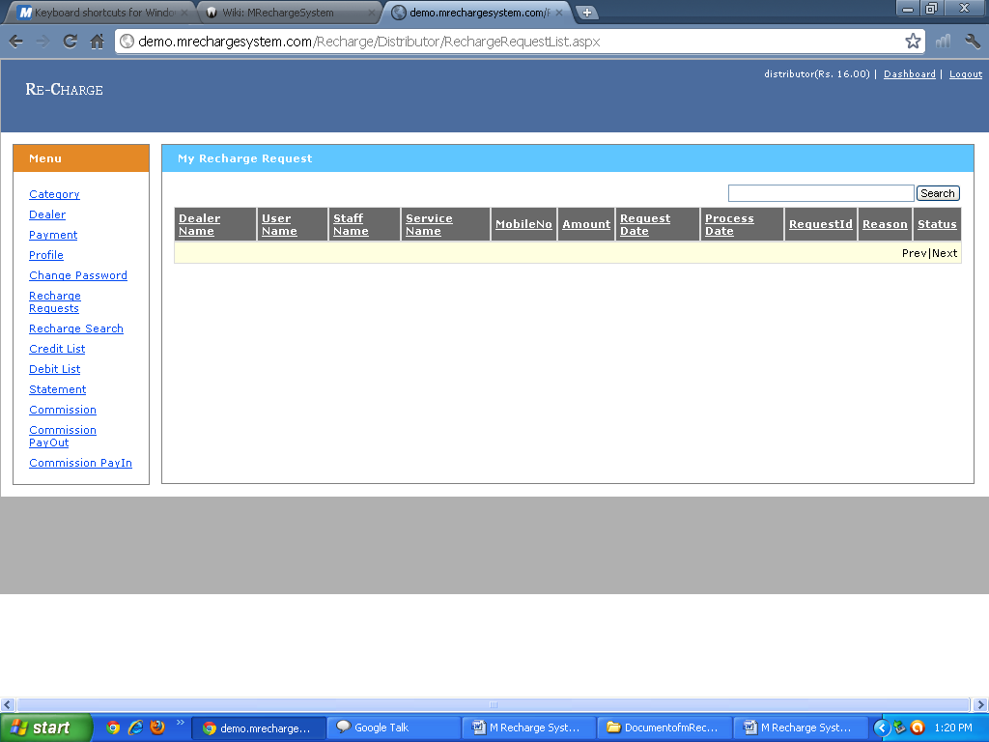
8) Recharge Search: Distributor can see that how much Recharge done by dealer and Using Which Service.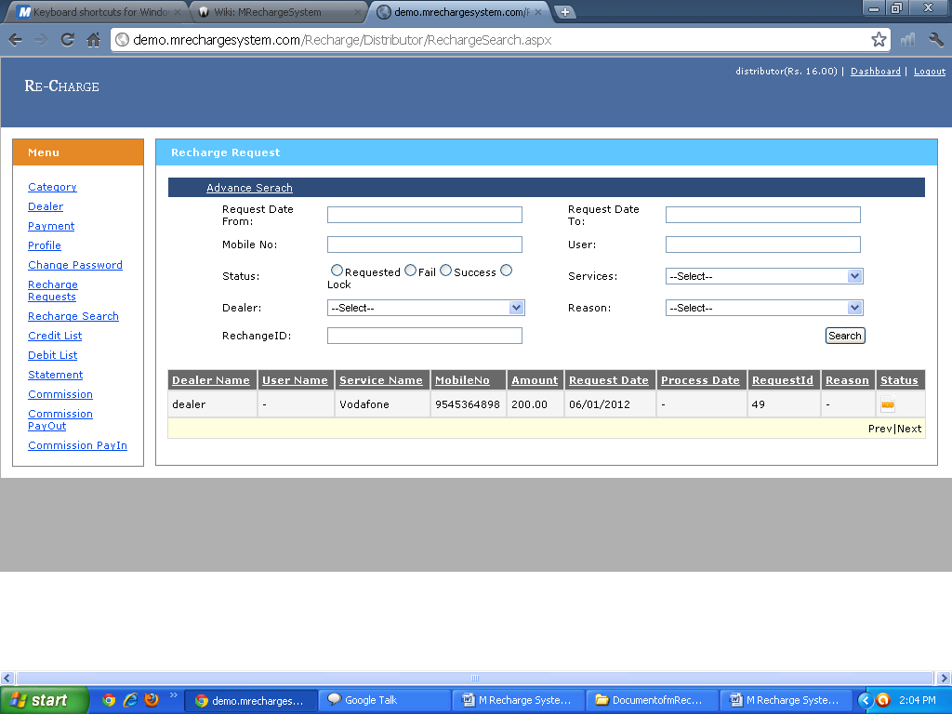

9) Credit List:Distributor can see the Credit List and see the Transaction Details and Status and used AdvanceSearch option for Finding particular infromation.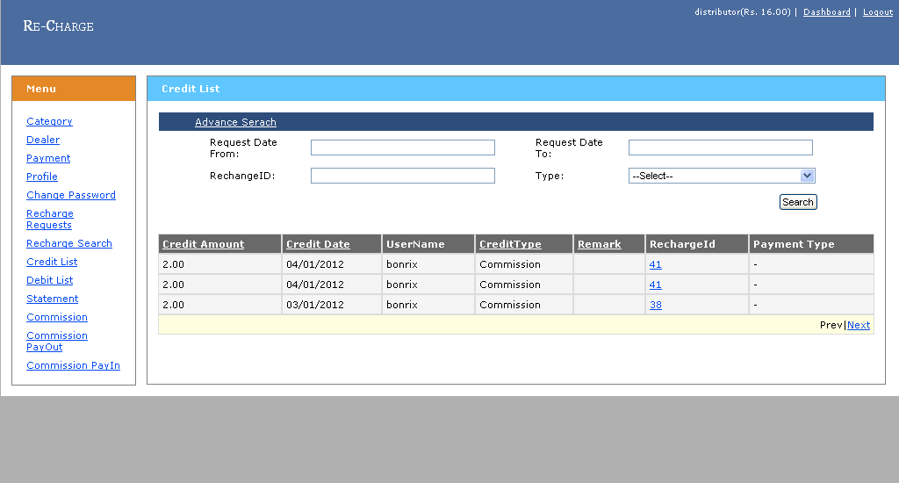
10) Debit List: Distributor can see the Debit List and see the Transaction Details and Admin can also used Advance Serch for finding particular user .
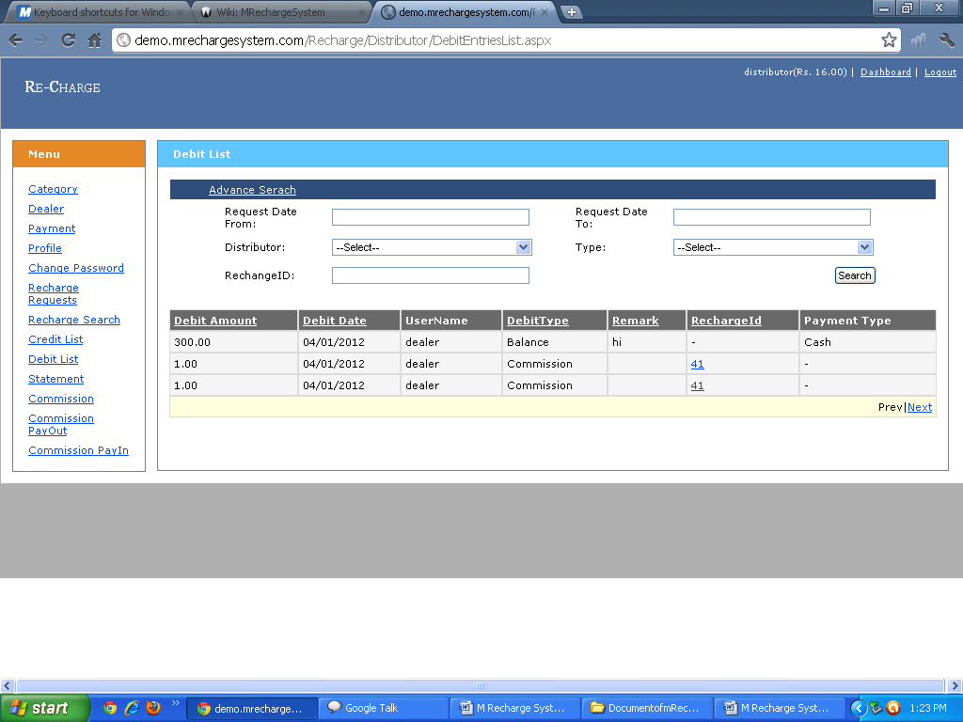

11)Statement: Distributor can See How many and Which Type of Transcation Perfrom Dealer.
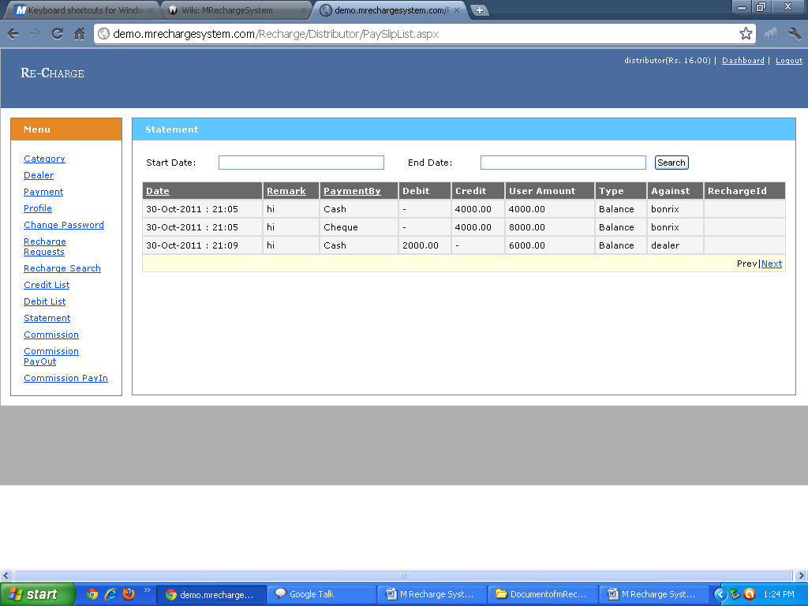
12) Service Commission: Distributor can decide How much will be apply the particular Services and Distributor can Also Update This Commision

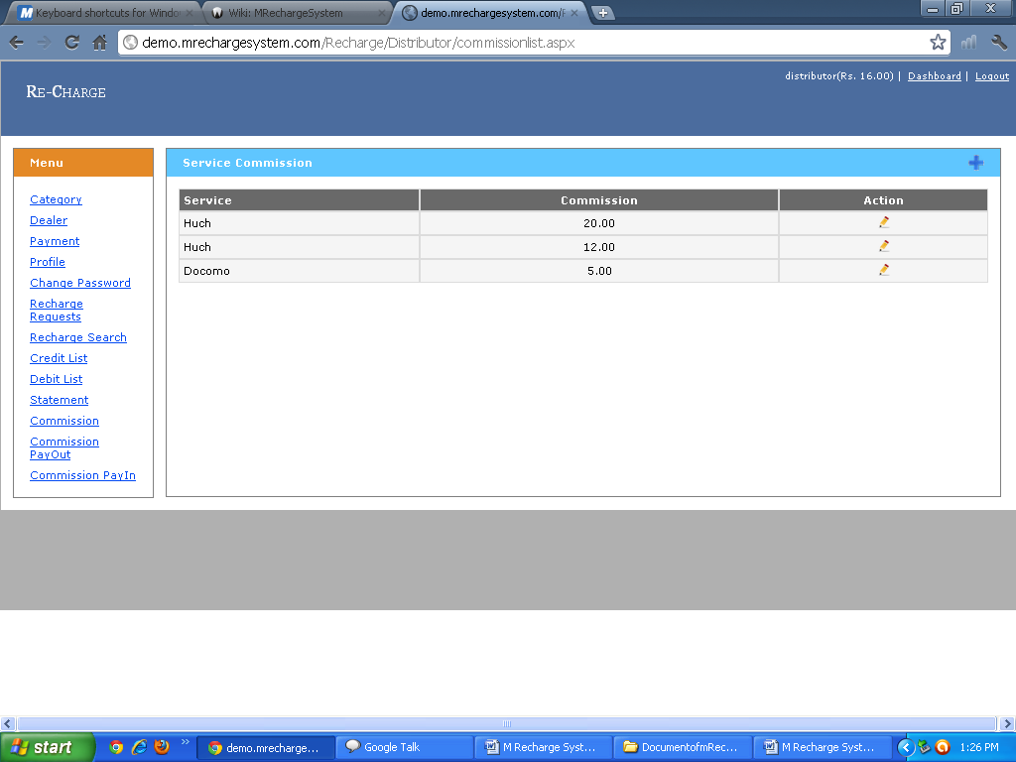

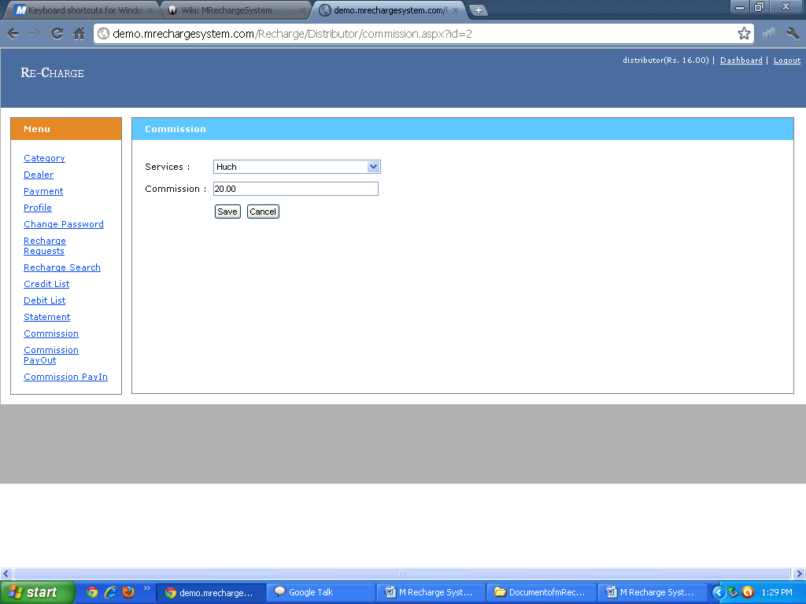
13) Commission Payout: Distributor can see That Howmany Payment He Paid Through Particular Services and also find the total Amount Of Service and Admin can also Advance search for finding Commission for Particular Service
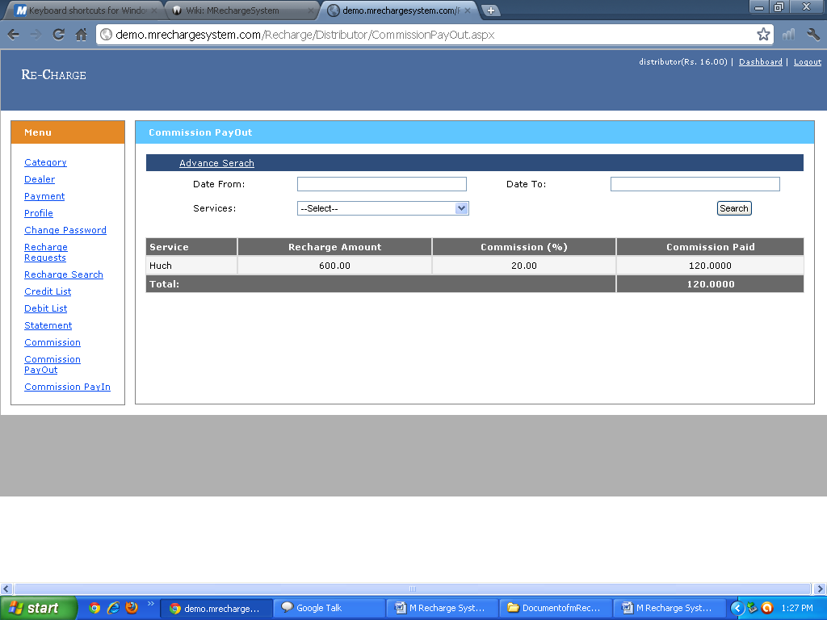

14) Commission Pay in: Distributor can see That Howmany Payment He Get Through Particular Services and also find the total Amount Of Service and Admin can also Advance search for finding Commission for Particular Service.
